SIX WEEKS INDUSTRIAL TRAINING

ON

**BILLING SYSTEM**

AT

**ACADVIEW**

Submitted in partial fulfillment of the requirement for the award of the degree of

**BACHELOR OF TECHNOLOGY**

**IN**

**COMPUTER SCIENCE AND ENGINEERING**

**Submitted By**

**Aarushi Sharma**

**11602173**



**DEPARTMENT OF COMPUTER SCIENCE AND ENGINEERING**

**DAV UNIVERSITY,SARMASTPUR,**

**JALANDHAR-144012**

**CERTIFICATE**

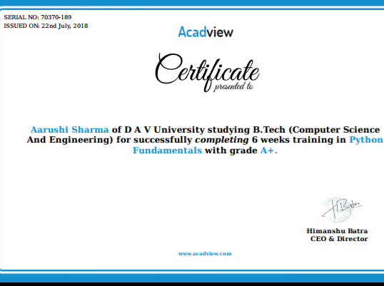

**DECLARATION**

I hereby declare that the Industrial Training Report is an authentic record of my own work as requirements of Industrial Training during the period from 6 June 2018 to 20 July 2018 for the award of degree of B.Tech in Computer Science and Engineering, DAV University, Sarmastpur , Jalandhar.

**Date:11 October 2018 Aarushi Sharma**

**11602173**

**ACKNOWLEDGEMENT**

I express my gratitude to all those who helped us in various stages of the development of this project. First, I would like to express my sincere gratitude indebtedness to Dr. Rakesh Kumar Mahajan (Vice-Chancellor), Dr. Jasbir Rishi (Dean Academics) and Er. Nishi (Coordinator, Department of Computer Science and Engineering) DAV University for allowing me to undergo the Six weeks industrial training at Acadview I am also thankful to all faculty members of Department of Computer Science and Engineering, for their true help, inspiration and for helping me for the preparation of the final report and presentation. Lastly, I pay my sincere thanks and gratitude to all the Staff Members of DAV University for their support and for making our training valuable and fruitful.

**TABLE OF CONTENT**

|  |  |  |
| --- | --- | --- |
| **Sr. No.** | **TITLE** | **PAGE NO.** |
| 1 | Introduction | 1 |
| 2 | Billing System | 10 |
| 3 | Objective | 12 |
| 4 | Work Plane | 14 |
| 5 | Coding and Implementations | 17 |
| 6 | Conclusion | 22 |
| 7 | References | 13-19 |